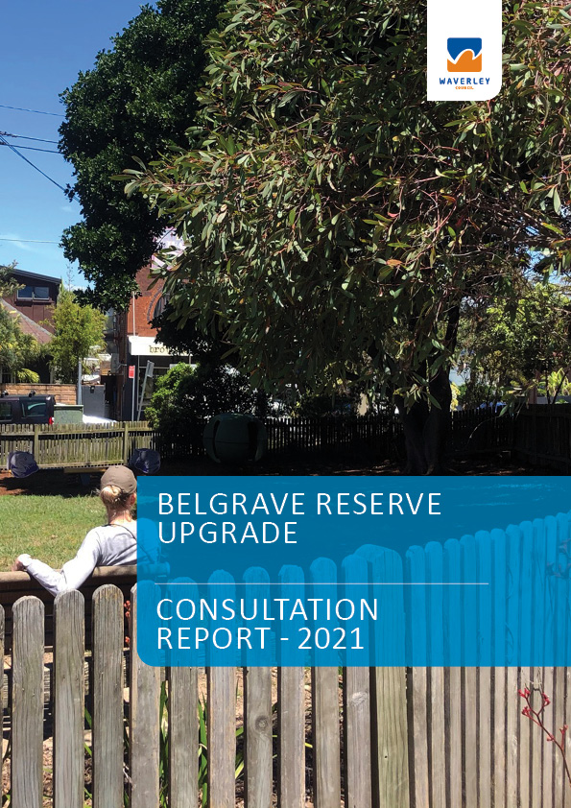

Waverley Council acknowledges the Bidjigal and Gadigal people, who traditionally occupied the Sydney Coast and we acknowledge all Aboriginal and Torres Strait Islander Elders both past and present.

Contents
Background 2
Objectives 2
Engagement methodology and data overview 2
The overall feedback: 3
Next steps: 4
Appendix A – flyer and distribution map 5
Appendix C – social media posts 6
Appendix E- Enewsletter 7
Appendix F - posters 8

Background
This is the second consultation stage for Belgrave Street Reserve. Council officers consulted with previous participants, residents who live near the park, businesses across the street and the general community to confirm the concept design reflects the feedback provided in the previous stage.
Phase 3
Concept design consultation
Phase 1
First round community consultation
Phase 2
Consultation feedback under review
Phase 4
Plan adopted by Council. Start detailed design
Phase 5
Construction
We are here

Objectives
The overall objectives of community consultation were to:
- Seek public input on the Belgrave Street Reserve concept design, providing clear description of how their previous feedback was used and provide the results to councillors to make a final decision by February 2022.
- Inform the community we are progressing on Council’s Play Space Strategy

Engagement methodology and data overview
The engagement methodology aligned with the IAP2 spectrum for public participation. Sitting in ‘consult’ on the spectrum.
A range of methods were used to maximise opportunities for community participation. These are detailed in the table below alongside key data.

Method | Overview | Date | Response
Have Your Say website | Council’s Have Your Say Waverley website had a dedicated page for this project: haveyoursay.waverley.nsw.gov.au/belgrave | 25 Nov to 23 Dec | 119 visits to the page
Flyer | Flyer dropped to residents around the park. See appendix A for full extent | WC 25 Nov | 18 QR code scans
Media release | Distributed at the beginning of the project
Social media posts (Facebook) | Theme: consultation open | 25 Nov 2021 | 822 reach  3 engagements
Social media posts (Instagram) | Theme: consultation open | 25 Nov 2021 | 985 reach  18 likes
Posters | Placed around the park |  | 4 QR code scans
Have Your Say Day | One x HYS day at Belgrave Reserve | 11 Dec | 1 person spoken to
Enews – Waverley Weekly | Asked readers to provide feedback on the concept design. | 3 Dec | 7243 received  2795 opened  46 clicked on the article
Engagement enewsletter | HYS enews sent to 7287 | 23 March | 7287 received

The overall feedback:
The community was consulted between 25 Nov – 23 Dec 2021. Responses were provided to council in the following formats:
- 10 survey results online
- 1 in person on “Have Your Say” day
- 2 emails
Given that this was the 2nd round of consultation for a small pocket park, the low turnout was not unexpected. Most responses were very supportive of the proposed concept design overall. The breakdown survey results are as follows:
- Very supportive (60%)
- Supportive (10%)
- Neutral (10%)
- Unsupportive (10%)
- Very unsupportive (10%)
- In addition, both email respondents and the single person from the “Have Your Say” day expressed support
Council Officers had conversations with residents adjacent the park on Murray and Belgrave Street. They discussed the installation of new low planting and turf and the removal of the concrete slab between the Reserve and the residence to accommodate the new greenery and path to the park. The resident was supportive of Council's proposal.
Key trends in user behaviour:
- Users visit on a daily or weekly basis
- 50% spend less than 10 minutes and 30% spend up to 30 minutes
- Main reasons for visiting are to relax and use the playground
- All users walked to the park
- 60% users visit with children
- All respondents lived locally
Key written suggestions from the community are:
- New synthetic spongey material under play equipment rather than bark
- Swing and slides in the playground
- Keep Kangaroo Paws
- Provide edging around mulch
- Keep wooden fence
- Additional seats and tables
- New gate at southern park entry
- Park too small for ball games
- Just a picnic spot rather than playground

Next steps:
The Open Space Recreation team reviewed these suggestions and made the following updates to the concept design:
- Additional seating/ table
- Installation of a gate on southern park exit for the safety of children
- Transplant Kangaroo Paws (where feasible)
- In addition, location of play equipment has been adjusted to accommodate the seat/ table setting. This is also to provide more space for picnics towards the northern end of park
Other suggestions cannot be accommodated due to site limitations, being against majority preference and/or lack of space (particularly for large pieces of play equipment

Appendix A – flyer and distribution map
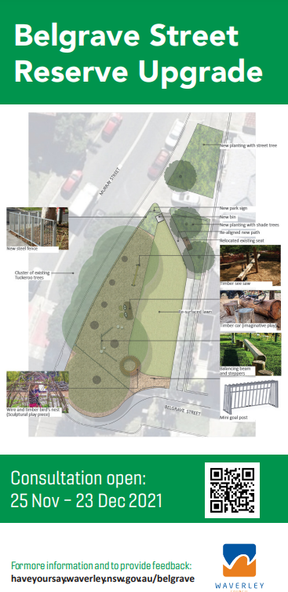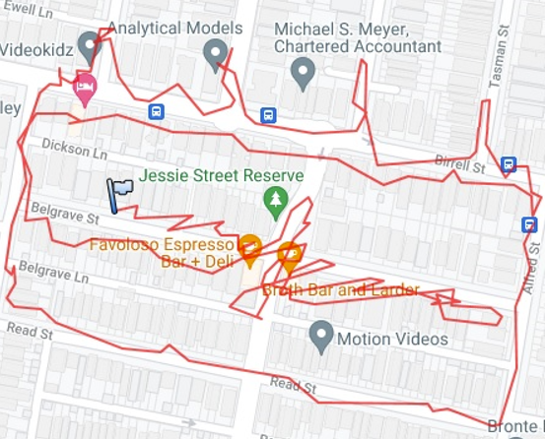

Appendix C – social media posts
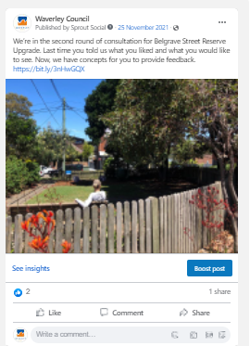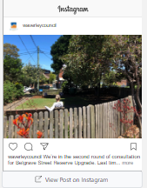

Appendix E- Enewsletter
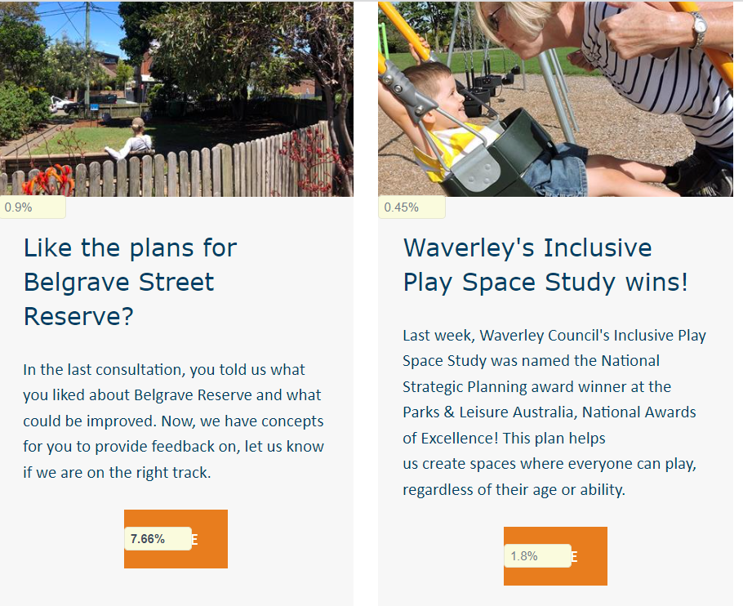
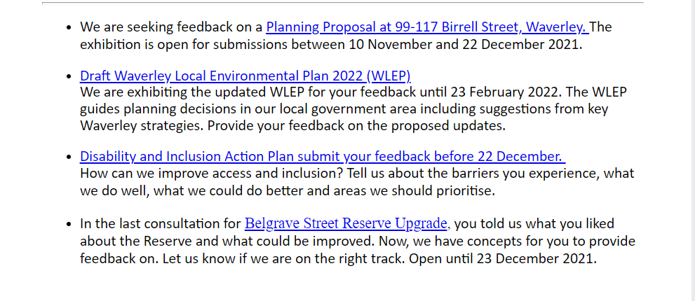

Appendix F - posters
