Bondi Pavilion Housewarming Program
Introduction:
Bondi Pavilion's Housewarming Program is a new artist residency opportunity celebrating the re-opening of the iconic Bondi Pavilion. The program will welcome artists into the building before it fully opens to the public, filling its spaces with art and new ideas.
The aim of the program is to provide space, opportunity and financial support for artists to:
- develop new ideas
- focus on their creative practice
- collaborate with other creatives
- engage with Waverley’s local landmarks and local community.
Open to artists from all disciplines and levels of experience, we will support up to six residencies across four weeks in May and June 2022.
We are seeking proposals from projects that respond to some or all of the following objectives and themes:
- Exploration of bold and engaging ideas that encourage community participation in the development or presentation of the project.
- Creation of new, locally made works that celebrate the unique qualities of Waverley’s environment or community and make us consider them in a new light.
- Creation of opportunities for creatives and audiences who have been historically under-represented, including people who are Aboriginal and Torres Strait Islander, Culturally and Linguistically Diverse (CaLD), LGBTQI+, d/Deaf or people with disability.
Expressions of interest close 5pm Monday 31 January 2022.
Register for the information session on Thursday 13 January, 12pm here.
Contact us at: artsopportunities@waverley.nsw.gov.au

Eligibility:
- This program supports individual artists and project group/companies of up to five artists.
- Applications from local artists and those with strong ties to the Waverley area are strongly encouraged.
- Applications from artists who identify as Aboriginal and/or Torres Strait Islander, Culturally and Linguistically Diverse (CaLD), LGBTQI+, d/Deaf or people with disability are strongly encouraged.
- Projects that embrace and promote environmentally sustainable practices are encouraged.
- Collaborative proposals and cross-disciplinary projects are encouraged, and proposals of any artform will be considered.
- Applicants must have an active ABN, be Australian citizens or permanent residents and aged 18 years or older.
Residency:
- Residencies fall within 23 May – 18 June 2022
- Residencies are 1-4 weeks in length, with access to the building available from 9am-6pm, Monday - Saturday.
- All projects will have a dedicated space for the duration of the residency.
What we provide:
- Artist stipends.
- Venue – spaces vary from a fully equipped theatre to flexible multipurpose rooms.
- Technical equipment and limited technical support, to be negotiated with each selected artist/group if required.
- Private residency spaces, with dedicated common areas and scheduled opportunities to come together with other resident artists to share and collaborate.
- Access to the Bondi Story Room database of local research.
- Support from Waverley’s Arts and Culture team for local information and contacts where applicable.
Assessment Criteria:
A panel made up of Waverley Council’s Arts and Culture staff and industry peers will assess applications against the following selection criteria:
- Alignment with the Housewarming Program’s themes and objectives
- Quality of the project proposal and track-record of the artists
- Potential for the project to be part of future Waverley Council programs or events
- Benefit of the residency to the project.
FAQ:
How long should I apply for?
We will have a mixture of 1, 2, 3 and 4 week slots available to artists dependent on the specific creative project’s needs. Apply for what is most useful to you and your project.
Do I need to create a finished artwork?
There is no requirement to create any finished work as part of this program.
Can I have a showing/reading/invited audience/open studio as part of the residency?
Yes. If you choose to do so, there will be option to present your work-in-progress to an invited audience in during the residency.
Will Waverley Council program my completed work in the future?
Whilst future programming with Waverley Council is not guaranteed, artists are encouraged to think about the future life of the project for presentation at Waverley’s festivals, programming and events in 2023 and beyond.
What access measures are in place?
All spaces in Bondi Pavilion are wheelchair accessible and there are accessible bathrooms in the Pavilion. If you’d like to discuss other access needs for your residency, please email us at artsopportunities@waverley.nsw.gov.au and we can respond by phone or email.
If you require this EOI information in another format, or would like to submit your application in another format, please be in touch.
Can I talk to someone about my project before applying?
We are having an artist information zoom session on Thursday 13 January 2022, 12pm-1pm. Please join us to hear more about the program and to ask any questions. Register here.
Do I need to bring anything to the residency?
Artists are responsible for any preparation required to commence their project and any extra equipment, materials and supplies they will require throughout the residency.
Is there accommodation provided?
No. It is the responsibility of the resident artists to make their own accommodation arrangements if from outside Sydney.
Do I need insurance?
Artists are required to obtain public liability insurance. Insurance for theft or damage to artists’ own equipment is recommended.
When will I know if I’m successful?
Successful applicants will be notified by March 2022.
How to Apply:
Please address the following questions and provide support materials.
- Project proposal – What are you planning to do? What ideas are you exploring and why? Who is involved? (max. 300 words OR 2-minute video response)
- Why you would like to be part of the Housewarming Program - What benefits will the residency offer to your project? How do you plan to spend your time during the residency period? How will you benefit from connecting to other resident artists? (max. 300 words OR 2-minute video response)
- How does your project align with the program’s themes and objectives - Does your project involve community participation? Does your project relate to the local environment or community? Who does your project create opportunities for? (max. 300 words OR 2-minute video response)
- Brief bio of all creatives (1 page max)
- Number of creatives involved (up to 5)
- Preferred dates and residency duration
- Preferred venue
- Whether you are interested in having a public outcome like a showing during your residency.

To apply, submit the following via Have Your Say Waverley.

Bondi Pavilion residency spaces
The iconic and newly refurbished Bondi Pavilion, situated at world famous Bondi Beach, is a two- storey accessible building that operates as a community, arts and cultural venue. It houses a variety of different sized meeting and events rooms, a gallery, theatre, pottery studio, music studios and recording room, a community radio space, a new digital history space - Bondi Story Room, and outdoor courtyards. All spaces are wheelchair accessible and there are accessible bathrooms in the building.
The spaces offered for the residency include:
Bondi Pavilion Theatre
Situated on the first floor with lift access, the theatre is a 223 seat tiered auditorium with 72 m2 stage area - playing area to mid stage curtain 5.9m x 8m with 2m x 8m backstage area. It has a lighting rig, audio and AV facilities including screen, projector, 2 x permanently installed cameras at the back of the theatre and live vision mixing and webcasting capabilities. In-house technical assistance is required to operate this equipment. An audio frequency induction hearing loop (AFIL) is available.

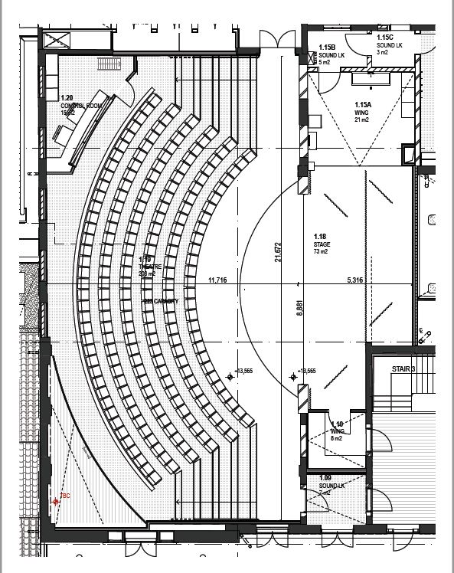

Seagull Room
Situated on the top floor of the Bondi Pavilion with lift access, this is a 196m2 multipurpose space with wooden floors and the original arched windows looking over the Northern Courtyard. The room has a general use PA, a drop-down projector and screen. Control of the room lighting, general audio system and projector is via touch screen and wall switches. Wi-fi based assisted listening system is available.
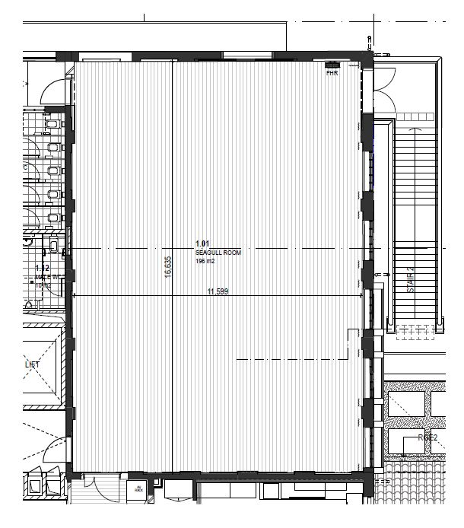
Ocean Room
Is situated on the top floor of the Pavilion, with lift access. The room is 5.15m x 2.6m, carpeted with a front door and additional side door that opens to the upstairs balcony facing the ocean. There is no technical equipment available in this room.

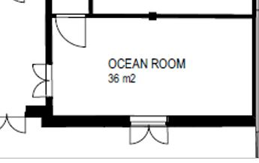

Yalagang Room
This is a flexible space situated on the ground floor of the Pavilion. It is a 97m2 space with a sprung floor and windows looking out over the Pavilion rear courtyard. There are some structural columns in the centre of the space, however the space is still fully functional and usable for most projects. There is a general PA, drop down projector and screen. Control of the room lighting, general audio system and projector is via touch screen and wall switches. Wi-fi based assisted listening system is available.

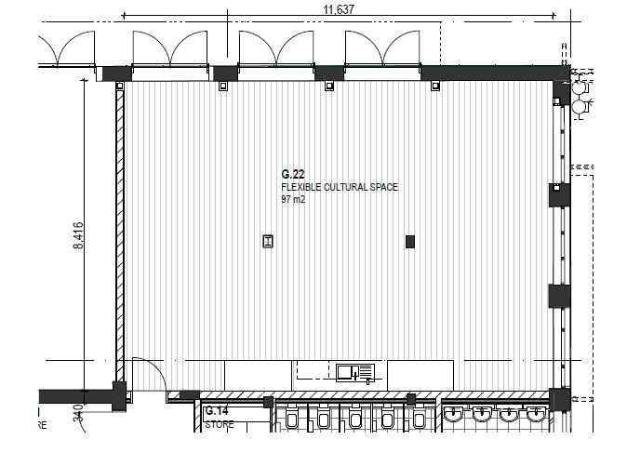

High Tide Room
Situated on the ground floor, this 200 m2 multipurpose room with wooden sprung floors and windows running along the entire room looks out to the Southern Courtyard. The room has a general use PA, a drop-down projector and screen. Control of the room lighting, general audio system and projector is via touch screen and wall switches. Wi-fi based assisted listening system is available.
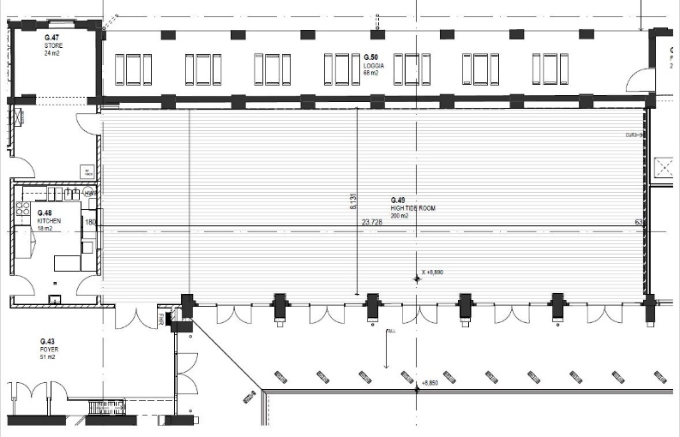
Music Studios
There are two music studios, approx. 50m2, situated on the ground floor of the Bondi Pavilion. A collection of studio microphones, mic stands, backline, DI’s, amps, small 16 channel mixer, programmable graphic equaliser and powered speakers for foldback monitoring are available in the studios.

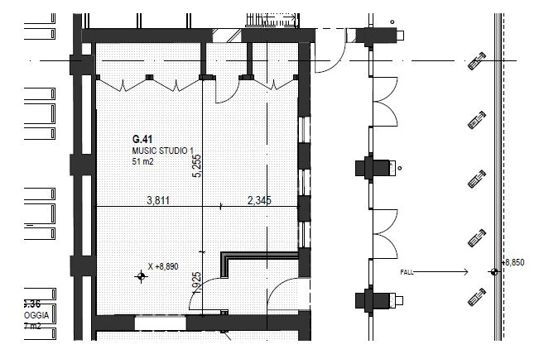
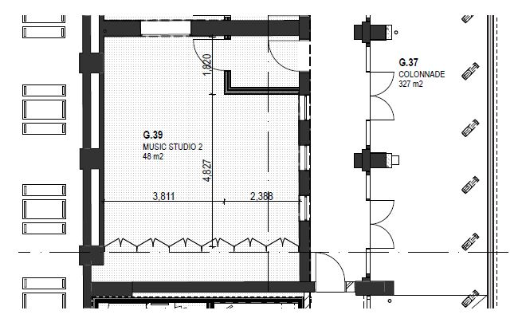

Music Control Room
The music recording studio is situated between studios 1 and 2 providing recording facilities for both Music Studio 1 and 2. The control room has a digital audio workspace, including computer, software and control surface. A podcast kit and digital keyboard are also available.

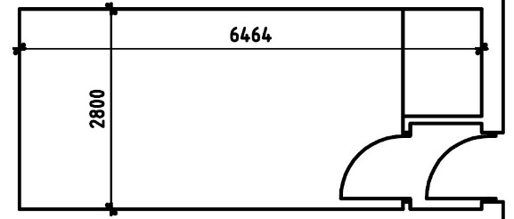

Pottery Studio
Situated at the northern end of the outdoor courtyards, the 45m2 studio is equipped with stationary and portable pottery wheels and kiln. There are work benches and storage shelves. Assistance would be required if firing is proposed as part of the studio use.
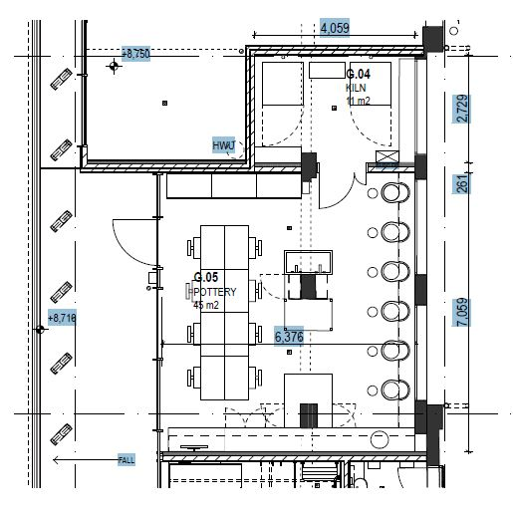
Outdoor Courtyards
The landscaped Guya (Southern) and Garu (Northern) courtyards are situated at the back of the Pavilion building and can be used separately or as an entire outdoor area. The cafes, Pottery Studio, Hightide Room, community radio and Yalagang Room all surround the courtyards. There are no built-in technical facilities in these areas.
